Name : Ch Mubashir

Sap : 56892

# Course : DS5-1 Data Warehousing and Bus.

# Lab Task : 01

# lab1_gpa_calculator.py – Python program.

# Python code :

import pandas as pd

def marks_to_gradepoints(marks):

    if marks >= 85: return 4.0

    elif marks >= 80: return 3.7

    elif marks >= 75: return 3.3

    elif marks >= 70: return 3.0

    elif marks >= 65: return 2.7

    elif marks >= 60: return 2.3

    elif marks >= 55: return 2.0

    elif marks >= 50: return 1.7

    else: return 0.0

n = int(input("Enter number of courses: "))

courses = []

for i in range(n):

    name = input(f"Course {i+1} name: ")

    marks = float(input(f"Enter marks for {name}: "))

    credit = int(input(f"Enter credit hours for {name}: "))

    gp = marks_to_gradepoints(marks)

    courses.append([name, marks, credit, gp, gp*credit])

df = pd.DataFrame(courses, columns=["Course", "Marks", "Credit Hours", "Grade Points", "Quality Points"])

gpa = df["Quality Points"].sum() / df["Credit Hours"].sum()

print(f"\nYour Semester GPA is: {gpa:.2f}")

df.to_excel("students_gpa_output.xlsx", index=False)

# Output :

# 2. students_marks.xlsx – Input file.

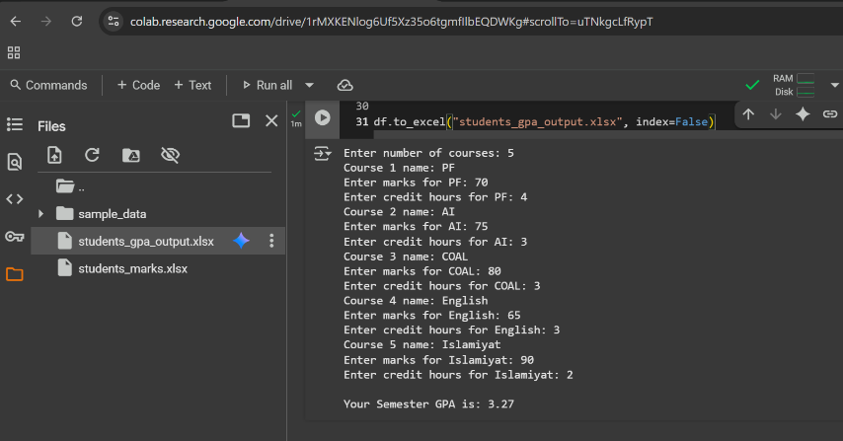

**Explanation :**

**marks_to_gradepoints function**

* This function converts marks into grade points.
* Example: If marks = 85, it returns 4.0; if marks = 60, it returns 2.3.

**Taking Input**

* First, the program asks how many courses you have.
* Then for each course, you enter:
  + Course name
  + Marks
  + Credit hours

**Course Data Storage**

* For each course, it calculates grade points and quality points (grade points × credit hours).
* All this data is stored in a list and then converted into a table using **Pandas DataFrame**.

**GPA Calculation**

* Formula used:

GPA=Total Quality PointsTotal Credit HoursGPA = \frac{\text{Total Quality Points}}{\text{Total Credit Hours}}GPA=Total Credit HoursTotal Quality Points​

* This gives your semester GPA.

**Output & Excel File**

* It prints your GPA on the screen.
* It also saves all your course details into an Excel file named **students_gpa_output.xlsx**.

**4. excel_gpa_calculator.xlsx – Excel-only GPA/CGPA calculator.**

**Explanation for Excel sheet GPA OR CGPA Calculation :**

## 1. **Marks → Grade Points (IF_GP)**

| **Marks (%)** | **Grade** | **Grade Points (IF_GP)** |
| --- | --- | --- |
| 85+ | A | 4.0 |
| 80–84 | A– | 3.7 |
| 75–79 | B+ | 3.3 |
| 70–74 | B | 3.0 |
| 65–69 | B– | 2.7 |
| 60–64 | C+ | 2.3 |
| 55–59 | C | 2.0 |
| 50–54 | C– | 1.7 |
| < 50 | F | 0.0 |

## 2. **Weighted Grade Points (WeightedGP)**

Each course has **credit hours**. The GPA system weighs courses by their importance.  
Formula in Excel:

= CreditHour * IF_GP

Example in our file:

* AI: 3 × 2.7 = **8.1**
* OOP: 3 × 4.0 = **12.0**
* PF: 4 × 3.7 = **14.8**

## **3. Total Credit Hours & Weighted GP**

At the bottom of the table:

* **Total Cr hr = 18**
* **Total Weighted GP = 46.9**

## 4. **GPA Calculation**

Finally, GPA is:

= TotalWeightedGP / TotalCreditHours

From our sheet:

GPA=46.918=2.605556\text{GPA} = \frac{46.9}{18} = 2.605556GPA=1846.9​=2.605556

## 5. **CGPA Calculation (Across Semesters)**

If you have multiple semesters:

* Add **all weighted grade points** across semesters.
* Add **all credit hours** across semesters.
* Divide the two:

CGPA=∑Weighted GP (all semesters)∑Credit Hours (all semesters)\text{CGPA} = \frac{\sum \text{Weighted GP (all semesters)}}{\sum \text{Credit Hours (all semesters)}}CGPA=∑Credit Hours (all semesters)∑Weighted GP (all semesters)​

**In Short (Excel Flow):**

1. Marks → GP (via IF/IFS formula).
2. GP × Credit Hours → Weighted GP.
3. Sum all credit hours & weighted GP.
4. GPA = Weighted GP ÷ Credit Hours.
5. CGPA = Same formula but with data from multiple semesters.